St Michael with St Thomas CE Primary School
Learn, Achieve, Love, Believe

Reception
Class Handbook
You will find the following information in the Reception handbook:

- Details of the adults that will be working with your child this year
- Information about homework
- Information about reading in this year group
- Details about PE days and swimming (if applicable to the year group)
- Dates of class worships and parent insight sessions
- Details of any Statutory Testing (Y1, Y2, Y4 and Y6 only)
- A copy of the Home – School agreement to sign

Staff working in Reception this year:
Class teacher: Mrs Fisher
KS1/KS2 Leader: Mrs Fisher
Teaching Assistant: Mrs Hughes
Student Teaching Assistant: Miss White
Homework
Homework will be sent on each Thursday and will be collected in each Tuesday.
We ask that all children read at least 5 times each week at home. This is to support them with:
- Becoming more fluent with their reading
- Developing stamina, allowing them to read more challenging texts
- Developing the speed in which they are able to read and comprehend at
- Developing Vocabulary
- Developing a love of books

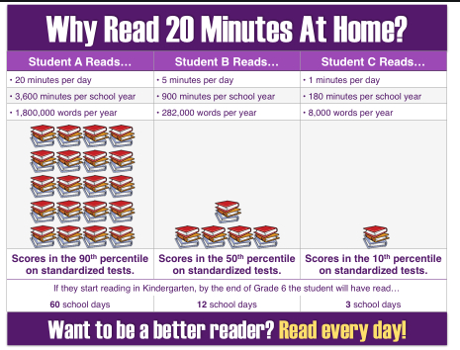
Reading in Early Years and KS1
In Reception and KS1, pupils are no longer reading by ‘Book Band’. Instead, children will have a reading book that is matched to the phonics sounds that they are learning in their groups. This is to ensure that they have time to practise and rehearse the learning taking place in the classroom. Children will be reassessed in their phonics groups each half term. These books are to be read often as children build fluency through reading known texts. They will be changed twice a week.
Children will also bring home a second book, which is a sharing book. This book is for adults to read with their child to build a love of books, enjoying the story, discussing the language, characters and plot. This book is not for adults to try and make children read, as this will contain sounds that they have not yet been taught through phonics. These books will be changed twice a week, but children can also change these books whenever they are ready to from the class library.

PE in Reception
This year our PE day will be a Wednesday.
We are asking that pupils come into school in their PE kits on their PE days – this should be a plain white t-shirt, black shorts and trainers. In the winter, pupils can wear a plain, black tracksuit over their PE kits to keep them warm.
The only thing that pupils need to bring into school and leave there is a small PE bag with their indoor pumps in.
Please ensure that tracksuits and shorts are plain black, with no stripes or logos down the sides.

