St Michael with St Thomas CE Primary School

***Learn, Achieve, Love, Believe***

Year 1 Class Handbook

2023 -2024

**You will find the following information in the Year 1 handbook:**

* Details of the adults that will be working with your child this year
* Information about homework
* Information about reading in this year group
* Details about PE days and swimming (if applicable to the year group)
* Times of the school day
* Dates of class worships and parent insight sessions
* Long Term Plan for the year
* Details of any Statutory Testing
* Maths and English Key Performance Indicators (KPIs)
* A copy of the Home – School agreement to sign

Staff working in Year 1 this year:

Class teacher: Miss Fisher

KS1/KS2 Leader: Mrs Fisher

Teaching Assistant: Mrs Bonnett

Teaching Assistant: Miss Mullarkey

**Homework**

Homework will be sent on each **Thursday** and will be collected in each **Tuesday**.

Weekly homework will consist of:

* Reading 5x a week
* Spellings – These can be practised via the games on Spelling Shed

<https://www.edshed.com/en-gb/login>

* Reading Eggs - This can be completed via the Reading Eggs website <https://readingeggs.co.uk/>

Spellings will be tested on a Tuesday or Wednesday and the scores recorded in the back of your child’s homework book.

Each half term, every class will have a homework challenge mat with a range of different activities on. We ask that all children complete **at least 2 activities from the mat per half term.**

All log ins and passwords are on stickers in the back of your child’s reading diary.

**Reading**

We ask that all children read at least 5 times each week at home. This is to support them with:

* Becoming more fluent with their reading
* Developing reading stamina, allowing them to read longer and more challenging texts
* Developing the speed in which they are able to read and comprehend at
* Developing Vocabulary
* Developing a love of books

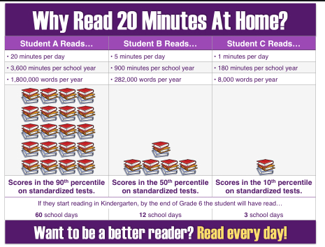

**Reading in Early Years and KS1**

In Reception and KS1, pupils are no longer reading by ‘Book Band’. Instead, children will have a reading book that is matched to the phonics sounds that they are learning in their groups. This is to ensure that they have time to practise and rehearse the learning taking place in the classroom. Children will be reassessed in their phonics groups each half term. These books are to be read often as children build fluency through reading known texts. They will be changed twice a week.

Children will also bring home a second book, which is a sharing book. This book is for adults to read with their child to build a love of books, enjoying the story, discussing the language, characters and plot. This book is not for adults to try and make children read, as this will contain sounds that they have not yet been taught through phonics. These books will be changed twice a week, but children can also change these books whenever they are ready to from the class library.

**Reading in KS2**

Once children have finished the Read Write Inc Phonics programme at the end of KS1, they will be assessed in their reading using the KS2 book bands. Children will be given a book that matches their reading level to read each night at home. Pupils will still be expected to read at least 5 times each week, although as they get older, they may read independently at some points throughout the week. All children who meet this home reading target, will receive Dojo points and an extra in class reward.

Studies have shown that reading progress in KS2 often slows, as parents believe that now pupils can read competently, there is less need for them to read aloud with an adult. This is a misconception and it is essential that pupils still have time to read aloud and to discuss texts with someone, especially as the books they are reading are becoming more and more challenging. Please support your child by listening to them read regularly and discussing the text with them.

Pupils in KS2 will be assessed each term and the book band that they are reading at may change. However, this is based on more than just the ability to read the words, and the pupil’s comprehension of the text is equally important. Pupils who read widely and from a variety of different types of texts, will develop their reading and comprehension skills far more efficiently.

In addition to their home reading books, pupils in Years 3, 4, 5 and 6 have access to Reading Plus which is an online school subscription to improve pupils’ reading speed, comprehension and understanding of vocabulary. Pupils will complete an initial assessment in school and will then receive their log in details. Pupils are expected to complete at least 2 Reading lessons via Reading Plus each week. This, coupled with reading at least five times per week at home, would mean that the child had met their home reading target for the week. A four-week trial period in May 2021 proved to be very effective (as shown in the anonymised data of a cross-section of pupils below) with the pupils who regularly accessed the online lessons seeing great improvement in their reading speed, comprehension accuracy and progression through the reading levels.

|  |  |  |  |  |  |
| --- | --- | --- | --- | --- | --- |
| **Reading lessons** | **Reading lessons 80%+** | **Total words read** | **Average comprehension** | **Rate gain (words per minute)** | **Level Gain** |
| 31 | 29 | 26,694 | 92.1% | 50 | 2.4 |
| 20 | 20 | 15,271 | 96.9% | 30 | 1.6 |
| 19 | 18 | 9,970 | 94.4% | 25 | 1.2 |
| 4 | 1 | 5,590 | 63% | 0 | 0 |

**PE in Y1**

This year our PE days will be Wednesday and Friday.

We are asking that pupils come into school in their PE kits on their PE days – this should be a plain white t-shirt, black shorts and trainers. In the winter, pupils can wear a plain, black tracksuit over their PE kits to keep them warm.

The only thing that pupils need to bring into school and leave there is a small PE bag with their indoor pumps in.

*Please ensure that tracksuits and shorts are plain black, with no stripes or logos down the sides.*

***No football/rugby kits will be allowed.***

**Times of the School Day:**

**Rec - Y3**

|  |  |
| --- | --- |
| 8.40am | School gates open |
| 8.45am | School starts |
| 8.55– 9.55am | Lesson 1 |
| 10am | Worship |
| 10.15am | Break time |
| 10.30 - 11:30am | Lesson 2 |
| 11:30am – 12pm | Phonics |
| 12pm – 12.45pm | Lunch |
| 12.45 -1pm | Wellbeing activities |
| 12.45/1.20pm – 3.15pm | Lesson 3, Lesson 4 and Lesson 5 |
| 3.15pm | Home time |

**Y4 - Y6**

|  |  |
| --- | --- |
| 8.40am | School gates open |
| 8.45am | School starts |
| 8.55 – 9.55am | Lesson 1 |
| 10am | Worship |
| 10.15am | Break time |
| 10.30 – 11.40am | Lesson 2 |
| 11.40am – 12.15pm | Lesson 3 |
| 12.15 – 1.00pm | Lunch |
| 1 – 1.15pm | Wellbeing activities |
| 1.15pm – 3.15pm | Lesson 4 and Lesson 5 |
| 3.15pm | Home time |

**Class Worship and Parent Insight Dates:**

|  |  |  |
| --- | --- | --- |
|  | **Venue** | **Date & Time** |
| **Class Worship** | School Hall | 1.5.2024 @ 9am |
| **Parent Insight sessions** | | |
| *Phonics* | Year 1 Classroom | 3.10.2023 @ 2:15pm |
| *Mathematics* | Year 1 Classroom | 18.1.2024 @ 2:15pm |
| *Phonics Parent Meeting – Phonics Screening Check* | Year 1 Classroom | 21.2.2024 @ 3:15pm |

**Year 1 Long Term Plan**

|  |  |  |  |  |  |  |  |
| --- | --- | --- | --- | --- | --- | --- | --- |
|  | **Autumn 1** | **Autumn 2** | **Spring 1** | **Spring 2** | | **Summer 1** | **Summer 2** |
| **ENGLISH** | **The Queen’s Hat**  **The Queen’s Handbag** – Steve Anthony | **Orion and the Dark –**Emma Yarlett  **Tidy** – Emily Gravett  **The Jolly Christmas Postman** | **Lost and Found –** Oliver Jeffers  **How to Catch a Star –**Oliver Jeffers | **Moles Star –**Britta Teckentrup | | **Traditional Tales**    **Cinderella**  **The Three Little Pigs**    **UNICEF – Right to a safe home** | **The Day the Crayons Quit**  **The Day the Crayons Came Home**– Oliver Jeffers |
| Genre | | | | | | |
| **Entertain:**  Simple and repetitive sentences   List – Suitcase for visiting London.  Rhyming strings and couplets  Story sequencing (including oral retell)  Character description of the Queen  Setting description of one of the landmarks.    **Inform:**  Letter from the Queen  Postcard to the Queen from children | **Entertain:**  Description - setting  Writing in the role as character  Predictions based on beginning and end of a story  Description - Orion  Personal narrative about being afraid  Writing a list of places where dark can be found  Question writing – hot seating a character  Planning and inventing a new story – overcoming a fear  Character Description - Jolly Postman  Poetry – Christmas acrostic poem | **Entertain:**  Narrative: Retelling events  Poetry – Senses (How to Catch a Star)  Recount –  postcard/recount in role  **Suggesting ways to get to the south pole**    **Inform**:  Radio/TV script for missing person  Non-chronological report – Artic (animals, equator)  Setting description (Artic) | **Entertain:**  Sentence work based on prefix ‘un’  Letter of apology  Sentence work based on reading comprehension  Narrative  Poster    **Inform:**  Non-chronological report (Wolves) | | **Entertain:**   Narrative of the Traditional Tale told from a different perspective/ character  Diary entry (before & after)  Letter  Character description – comparing before and after (list using commas)  Diary entry using question marks and different pronouns  Innovated story – BME, time adverbials    **Inform:**   Formal invitation to the ball   Wanted poster for the Wolf/Cinderella | **Entertain:**  Predictions  Letters in role  Character description  Radio/TV script – missing crayon  Narrative |
| **MATHS** | **Numbers to 10**  **Addition and subtraction within 10**  **Shape and patterns** | **Numbers to 20**  **Addition and subtraction within 20** | **Addition and subtraction within 20**  **Calculation strategies**  **Multiplication and division** | **Time**  **Fractions**  **Numbers to 50** | | **Numbers 50 to 100 and beyond**  **Money**  **Addition and subtraction** | **Money**  **Measures: length and mass**  **Measures: capacity and volume** |
|  | Represent, compare and explore numbers within 10.  One more and one less  Doubling and halving  Represent and explain addition and subtraction.  Commutativity  Addition and subtraction facts  Identify, describe 2-D and 3-D shapes  Investigate repeating patterns  Use and follow instructional and positional language | Identify, represent, compare and order numbers to 20  Doubling and halving  One more and one less  Represent and explain  addition and subtraction strategies including ‘make ten’  Use known facts to add and subtract | Illustrate, explain and link addition and subtraction with equations  Apply ‘Make Ten’ strategy  Use language to quantify and compare difference  Model, explain and choose addition and subtraction strategies.  Share equally into groups  Doubling  Link halving to fractions  Add equal groups  Explore arrays | Read, write and tell the time to o’clock and half past on analogue clock  Sequencing daily activities  Whole and half turns linked to time  Identify half, and quarter of a shape or object  Find half and quarter of a quantity  2-digit numbers – represent, sequence, explore and compare.  Count in 2s, 5s and 10s  Describe and complete number patterns | | Read, write, represent, compare and order numbers to 100  One more / fewer, ten more / fewer  Identify number patterns  Name coins and notes and understand their value  Represent the same value using different coins  Find change  Explore addition and subtraction involving 2-digit numbers and ones  Represent and explain addition and subtraction with regrouping  Investigate number bonds within 20 | Compare and measure lengths and mass using cm and kg  Doubling and halving  Compare capacities, volumes and lengths  Explore litres  Apply understanding of fractions to capacity |
| **Subjects taught discretely throughout the year:** | | | | | | | |
| **SCIENCE** | **Animals including Humans**  **(Humans)**  **Seasonal Changes** | **Animals including Humans**  **(Animals)** | **Everyday Materials**  **Seasonal Changes** | | | **Plants**  **Seasonal Changes** | **Plants** |
| We will identify, name, draw and label the basic parts of the human body and say which part of the body is associated with each sense. | We will identify and name a variety of common animals including fish, amphibians, reptiles, birds and mammals that are carnivores, herbivores and omnivores.  We will describe and compare the structure of a variety of common animals (fish, amphibians, reptiles, birds and mammals, including pets) | We will identify and name a variety of everyday materials, including wood, plastic, glass, metal, water, and rock and describe the simple physical properties of a variety of everyday materials. | | | We will identify and name a variety of common wild and garden plants, including deciduous and evergreen trees and basic structure of a variety of common flowering plants. | We will work scientifically by: making tables and charts about the weather; and making displays of what happens in the world around them, including day length, as the seasons change. |
| Other topics we will be learning about are Seasonal Change and Working Scientifically. These will be taught as a rolling programme, which means that we will be visiting these topics a number of times over the year. | | | | | | |
| **PSHE & RSE** | **Throughout the year, we will use our Jigsaw PSHE materials:** | | | | | | |
| **Being Me in My World**  Feeling special and safe  Being part of a class  Rights and responsibilities  Rewards and feeling proud  Consequences  Owning the learning charter  FBV – Individual Liberty | **Celebrating Difference**  Similarities and differences  Understanding bullying and how to deal with it  Making new friends  Celebrating the differences in everyone  FBV – Tolerance for All | **Dreams and Goals**  Setting goals  Identifying success and achievements  Learning styles  Working well and celebrating achievement with a partner  Tackling new challenges  Identifying and overcoming obstacles  Feelings of success  UNICEF – Right to share their thoughts freely | | **Healthy Me**  Keeping myself healthy  Healthier lifestyle choices  Keeping clean  Being safe  Medicine safety/safety with household items  Road safety  Linking health and happiness  UNICEF - Right to health care, clean water, food and a clean environment | **Relationships**  Belonging to a family  Making friends/being a good friend  Physical conduct preferences  People who help us  Qualities as a friend and person  Self-acknowledgment  Being a good friend to myself  Celebrating special relationships  FBV – Mutual Respect | **Changing Me**  Life cycles – animal and human  Changes in me  Changes since being a baby  Differences between female and male bodies (correct terminology)  Linking growing and learning  Coping with change  Transition |
| **PE** | **Fundamental skills Games (invasion)** | **Fundamental skills Dance** | **Fundamental skills Gymnastics** | **Fundamental skills**  **Athletics** | | **Fundamental skills Games (net and wall)** | **Fundamental skills Games (striking and fielding)** |
|  |  |  |  |  | |  |  |
| **RE** | **We follow the Blackburn scheme of work to study the following topics throughout the year:** | | | | | | |
| Harvest/ My World  Jewish festival – Sukkot  My World, Jesus’ World  FBV – Tolerance for all | Christmas | Jesus was special | Easter | | Why is Baptism special? | God and creation |
| **The aim of this unit is to:**  Raise awareness that we harvest food all around the world and that we usually have plenty but others do not.  Help children understand that Jesus lived a long time ago and that the world we live in is very different to Jesus’ world over 2000 years ago. | **The aim of this unit is to:**  Deepen the children’s understanding of the true meaning of Christmas through emphasising that Jesus was a gift from God. | **The aim of this unit is to:**  Enjoy exploring these Bible stories that reveal Jesus’ power and divine nature.  Talk about how and why Jesus was special. | **The aim of this unit is to:**  Give children an opportunity to reflect upon the miracles of nature and new life during springtime.  To make links between the transformation of plants and animals and the Easter story in order to develop an understanding of the resurrection. | | **The aim of this unit is**  **to:**  Deepen children’s understanding of what it means to belong through exploring the celebration of baptism and the ways in which people of faith welcome babies. | **The aim of this unit is to:**  Give the children the opportunity to develop their perceptions and understanding of God. |
| **COMPUTING** | **Technology Around Us** | **Moving a robot** | **Digital Painting** | **Grouping Data** | | **Introduction to animation** | **Digital Writing** |
| **Education for a Connected World** | Health, well-being and lifestyle  Copyright and ownership  Online relationships  Online reputation  Privacy and Security | Health, well-being and lifestyle | Copyright and ownership | Copyright and ownership | | Health, well-being and lifestyle | Copyright and ownership  Privacy and Security |
| **HISTORY** |  |  | **1960s**  FBV – Democracy | **1960s**  FBV – Respect and Tolerance | |  |  |
|  |  |  | I know that the 1960s was a decade  I know that a decade is 10 years long.   I can make comparisons between school then and now.  I understand why significant events from the 1960s are still remembered today. | know why some significant people from the 1960s are still remembered and celebrated today.  I understand how technology had an impact on life in the 1960s  I am able to use timelines to order events from the 1960s  I know and am able to recall significant events from the 1960s | |  |  |
| **GEOGRAPHY** | **The United Kingdom** FBV – The Rule of Law | **The United Kingdom** |  |  | | **Lost and Found** | **Lost and Found** |
|  | I can name the four countries of the UK.  I know I live in England.  I can locate the four countries of the UK on a map of the UK.  I can identify characteristics of the four countries of the UK. | I know what a city is.  I can name the four capital cities of the UK.  I can locate the four capital cities of the UK on a map.  I know the city nearest to us.  I can locate where I live on a map.  I know the seas that surround the UK. |  |  | | I know the names of the seasons in the UK  I can name different types of weather  I know that we have more hours of daylight in Summer than in Winter.  I can make observations about the weather using description and some explanation. | I know the names of the seasons in the UK  I can name different types of weather  I know that we have more hours of daylight in Summer than in Winter.  I can make observations about the weather using description and some explanation. |
| **ART** | **Drawing – Spirals** | | **Painting – Exploring Watercolour** | | | **Printmaking – Simple Printmaking** | |
| I can draw from my finger tips, my wrist, my elbow, my shoulder, my body.  I can make a drawing using a continuous line for a minute or two.  I have made a sketchbook (or perhaps decorated the cover of a bought sketchbook) and I feel like it belongs to me.  I can draw from observation for a few minutes at a time.  I can make different marks with different drawing tools. I have seen the different marks I can make with a soft pencil, a graphite stick and a handwriting pen.  I have explored how water affects the graphite and pen, and explored how I can use a brush to make new marks.  I can make choices about which colours I’d like to use in my | | I can explore watercolour and understand the different effects I can achieve.  I can work without an end goal in mind – letting the paint lead me.  I have had the opportunity to see the work of other artists who use watercolour, and share my thoughts about their work.  I can name and use primary colours, and begin to understand how colours mix to make secondary colours.  I can understand that we all see different things in the artwork we make. We all have a different response.  I can think about the marks I make, and develop them further. | | | I can make simple prints using my hands and feet.  I can explore my environment and take rubbings of textures I find.  I can use my rubbings to make an image.  I can push objects I find into plasticine and make prints.  I can cut shapes out of foam board and stick them on a block to make a plate. I can print from the plate.  I can draw into the surface of the foam board and print from the plate.  I can use colour, shape, and line to make my prints interesting.  I can create a repeat print.  I can create a symmetrical or sequenced print.  I can use my sketchbook to collect my prints and test ideas. | |
| **DT** |  | **Levers and Sliders** |  | **Zoo enclosures** | |  | **Food – Super Salad** |
|  | I will be able to use tools safely to make a moving picture that incorporates a simple lever or slider.  I will be able to use given techniques to practise my making skills and as a starting point for developing my own ideas, I will be able to talk about how simple moving products work. |  | I will know what a freestanding structure is and give examples.  I will know how to make freestanding structures stronger, stiffer and more stable.  I will know and use technical vocabulary relevant to the project. | |  | I will gain an understanding of the properties, including taste, texture and appearance, of a range of fruit and vegetables.  I will prepare and combine ingredients into a salad; use basic tools safely; recognise that it is important to eat more fruit and vegetables. |
| **MUSIC** | **My Musical Heartbeat** | **Dance, Sing and Play!** | **Exploring Sounds** | **Learning to Listen** | | **Having Fun with Improvisation** | **Let’s Perform Together!** |
| Use body percussion, instruments and voices | Find and keep a steady beat together | Begin to move in time with a steady beat/pulse. | Copy back simple long and short rhythms with clapping. | | Copy back singing simple high and low patterns. | Start to know and demonstrate the difference between pulse, rhythm and pitch. |
| **Trips/Visits** |  | Trip to Knowsley Safari Park (Local History Week)  Pantomime |  |  | | 1960s Day – in school | End of year trip |

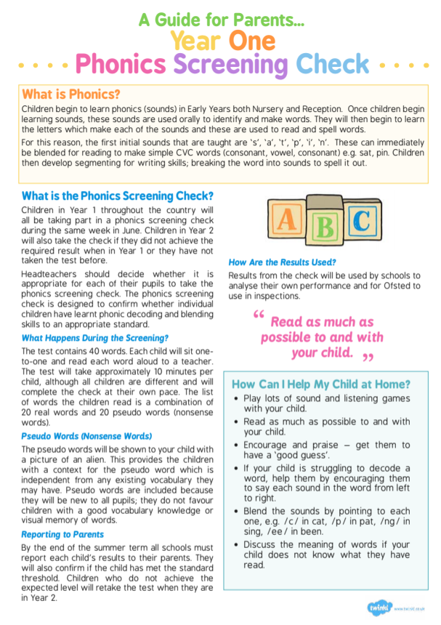

**Year 1 Phonic Screening Check**

What can you do to help at home?

1. Use ‘Special Friends’, ‘Fred Talk’, read the word, to read words.
2. Practise reading sounds speedily - ‘review, review, review’.
3. Listen to your child read their *Read Write Inc*. Storybook every day.

There are free video tutorials on our website – [www.ruthmiskin.com](http://www.ruthmiskin.com)

Select ‘Find out more’ at the top, then ‘Parents’ from the drop-down list:

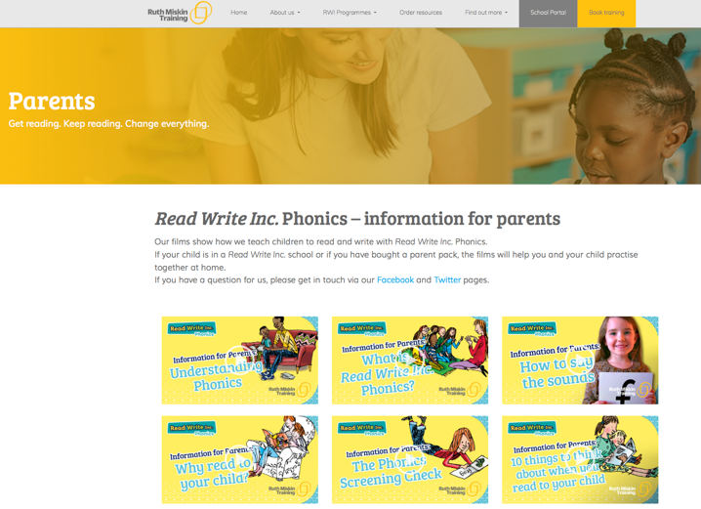

We’re also on Facebook – [www.facebook.com/miskin.education](http://www.facebook.com/miskin.education)

Free e-books for home reading:

<http://www.oxfordowl.co.uk/Reading/>

Previous phonics screening check materials: <https://www.gov.uk/government/publications/phonics-screening-check-2022->

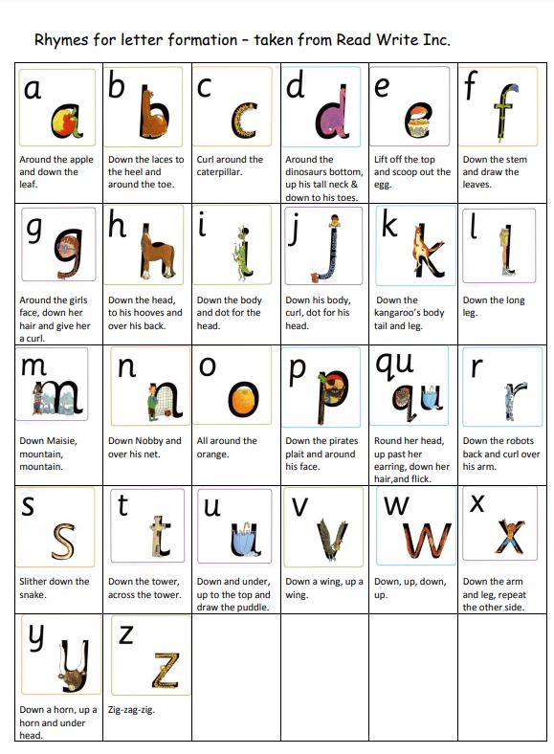materials

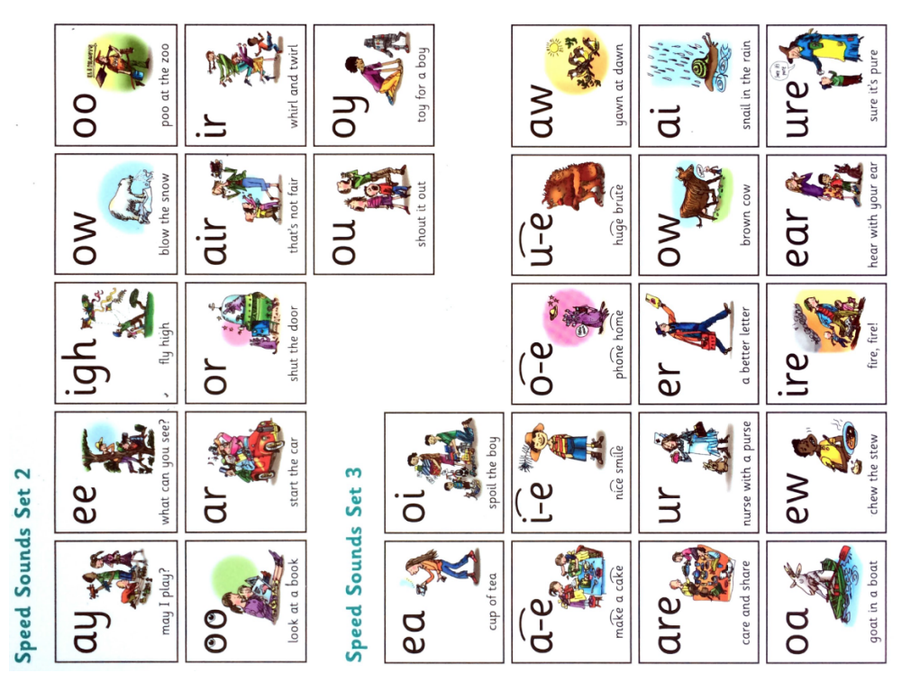



**St Michael with St Thomas CE Primary School**

**Y1 Key Performance Indicators (KPIs) for Reading, Writing and Maths**

This booklet gives details of the Key Performance Indicators (KPIs) that children in this year group are expected to meet by the end of the year. Teachers will be assessing your child against their progress towards these KPIs throughout the year, and will report on whether they are meeting age related expectations.

2023-2024

|  |  |  |  |
| --- | --- | --- | --- |
| **Year 1 Reading KPIs** | **Assessment Period 1** | **Assessment Period 2** | **Assessment Period 3** |
| Read aloud accurately books that are consistent with their developing phonic knowledge. |  |  |  |
| Apply phonic knowledge and skills as the route to decode words. |  |  |  |
| Respond speedily with the correct sound to grapheme for the 44 phonemes. |  |  |  |
| Recognise and use the different ways of pronouncing the same grapheme; e.g. ow in snow and cow. |  |  |  |
| Read accurately by blending sounds in unfamiliar words. |  |  |  |
| Make personal reading choices and explain reasons for choices. |  |  |  |
| Check that texts make sense while reading and self-correct. |  |  |  |
| Demonstrate understanding of texts by answering questions related to who, what, where, when, why, how. |  |  |  |
| Identify and discuss the main events in stories. |  |  |  |
| Identify and discuss the main characters in stories. |  |  |  |
| Recall specific information in fiction and non-fiction texts. |  |  |  |
| Make predictions based on what has been read so far. |  |  |  |
| Listen to what others say. |  |  |  |
| **Year 1 Writing KPIs** | **Assessment Period 1** | **Assessment Period 2** | **Assessment Period 3** |
| Orally compose and hold in memory whilst writing, simple sentences which make sense. |  |  |  |
| Write simple sentences that can be read by themselves and others. |  |  |  |
| Separate words with spaces. |  |  |  |
| Use punctuation to demarcate simple sentences (capital letters and full stops). |  |  |  |
| I can begin to join sentences and clauses using and or but. |  |  |  |
| Sequence ideas and events in narrative. |  |  |  |
| Re-read every sentence to check it makes sense and correct accordingly. |  |  |  |
| Read aloud their writing audibly to adults and peers. |  |  |  |
| Spell words using the 40+ phonemes already taught, including making phonically plausible attempts at more complex words. |  |  |  |
| Name the letters of the alphabet in order. |  |  |  |
| Use letter names to distinguish between alternative spellings of the same sound. |  |  |  |
| Hold a pencil with an effective grip, form lower-case letters correctly – starting and finishing in the right place, going the right way round, correctly oriented. |  |  |  |
| **Year 1 Maths KPIs** | **Assessment Period 1** | **Assessment Period 2** | **Assessment Period 3** |
| Demonstrate an understanding of place value of 10s and 1s in a two-digit number, using resources to support them if necessary (e.g. representing a two-digit number using resources for tens and ones; comparing two numbers up to 50 to identify the larger and smaller number without apparatus). |  |  |  |
| Order and compare numbers up to 100, saying which is bigger and which is smaller. |  |  |  |
| Use number bonds and related subtraction facts within 10 (bonds to 4, 5, 6, 7, 8, 9, 10) as well as the addition of any single digit to 10. |  |  |  |
| Add and subtract two-digit number and ones within 20 required (e.g. 13 + 5; 17 – 4), they can demonstrate their method using concrete apparatus or pictorial representations. They can add a ones digit number and a ones digit number using number bond knowledge and are beginning to partition through 10 eg 7 + 8 = 8 + 2 + 5. |  |  |  |
| Work out missing numbers within addition and subtraction calculations to 20 using number bond recall and knowledge of inverse relationships. |  |  |  |
| Count in twos, fives and tens from 0 and use counting strategies to solve problems (e.g. count the number of chairs in a diagram when the chairs are organised in 3 groups 2 by counting in twos or by counting in tens when they are in groups 10). |  |  |  |
| Recall doubles and halves to 10 and 10 + 10 (e.g. pupil knows that double 2 is 4, double 5 is 10 and half of 10 is 5). |  |  |  |
| Recognise one half as two equal parts or a quarter as four equal parts in a shape or quantity. |  |  |  |
| Read the time on the clock to the nearest 30 minutes. |  |  |  |

As a pupil at St Michael with St Thomas, I will try to –

* Come to school each day and on time
* Be helpful and caring to everyone in school
* To follow the school rules Ready, Respectful, Safe by making good behaviour choices and respect all adults in school
* Always tell the truth
* Be friendly to everyone in school
* Listen carefully to adults and follow their instructions
* Work hard and do my best
* Enjoy school

Child’s signature……………………………………………………

**St Michael with St Thomas**

**Church of England**

**Primary School**

**HOME AND SCHOOL AGREEMENT**



***Learn, Achieve, Love, Believe***

SCHOOL WILL-

* Provide a Christian Education with daily acts of worships and visits to Church
* Ensure that parents and children are treated with respect
* Ensure each child is cared for and kept safe
* Provide a friendly, caring environment
* Encourage and motivate children to learn
* Provide a bright stimulating environment
* Develop each child’s full potential
* Provide a rich and varied curriculum
* Cater for individual needs
* Promote respect, tolerance and good manners
* Assess pupils progress and inform parents
* Encourage and reward good behaviour
* Deal appropriately with children who make the wrong choices
* Respond appropriately to parental concerns
* Set firm, fair and consistent school rules – Ready, Respectful, Safe
* Have high expectations of all children
* Ensure that staff are available to speak to parents at the end of the school day or by appointment
* Keep parents informed with information related to school

Signed

Miss M Slingsby

Head teacher

PARENTS ARE EXPECTED TO-

* Deliver children to school on time, dressed in appropriate school uniform and appropriate to the weather
* Ensure children are alert and ready to work
* Be supportive of the school rules – Ready, Respectful, Safe
* Respect adults and children on the school premises
* Support school policies and guidelines outlined in the school prospectus, including the use of reasonable force as stated in the school policy
* Attend meetings with staff to discuss their child’s progress
* Read communication sent from school and respond appropriately
* Be supportive of the school and all members of the school family in social media use
* Provide school with information for emergency contact and any changes to their emergency contact
* Inform school of any changes in circumstances which may influence child’s learning or behaviour
* Inform school in writing by the end of the Spring term (before Easter holidays) if they wish to take their child’s books home at the end of the school year.
* I give permission for my child’s name to appear in the class handbook
* Provide appropriate PE and swimming kit
* Encourage children to respect school property
* Support their children with homework
* Collect children on time at the end of the school day

Signed

Parent/Carer

Date