16.09.2020.
Can I use number sense?

Look at all the different representations below. In your home learning book discuss what each one represents:
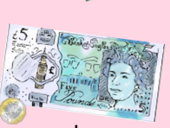
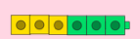
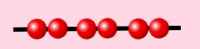
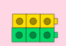
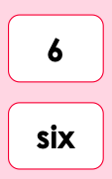
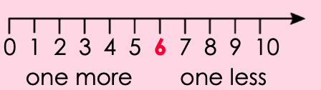
Explain how the cubes can show both an addition and also a multiplication. E.g.: 3 + 3 = 6

For your task today you are going to choose a number and create a poster which shows lots of facts about it. Use both pictures and diagrams to represent your number.

17.09.2020
Can I explore number names?

- Starting from the number 35 count in tens until you reach 105. Write this sequence of numbers in your home learning book.
- Write the number 53 in your home learning book. What number is 10 more? What number is 10 less?
- Look at the table of numbers below. Write down what you notice in each column. What is the same? What is different?
- Look at the table of numbers below. What do you notice in each row? What is the same? What is different? How many different digits are there?

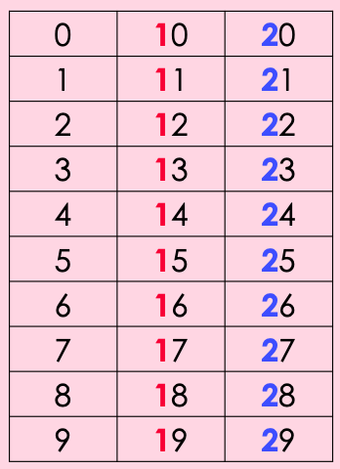

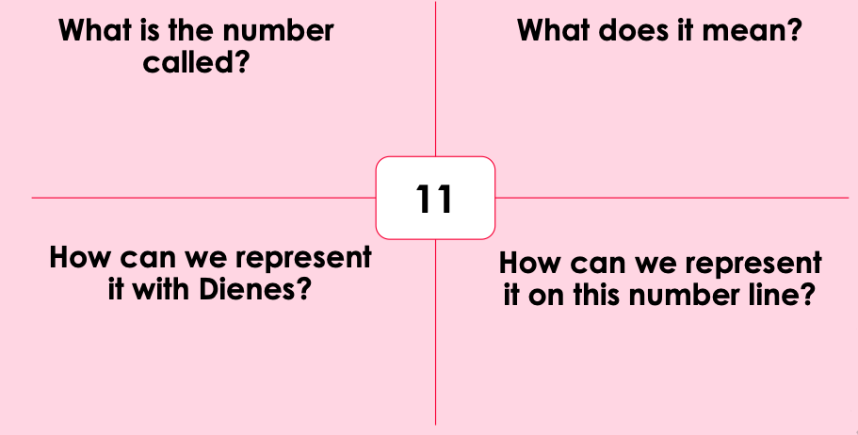
- Complete the table which focuses on the number 11. Next choose your own number and complete the blank table below.

18.09.2020
Can I compare numbers?

Look at the four numbers below. In your home learning book copy the grid and place the numbers within the sequence. Think about where does the number with the greatest value belong? Where does the number with the least value belong?
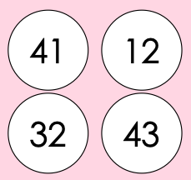

Now you are to create your own sequence of numbers using the grid again. Your numbers must be 2-digit numbers and must all be odd. What is the smallest 2-digit number you can place in your sequence? What is the highest, odd 2-digit number?

